**LED COB DOWNLIGHTS LIGHTS**

**ITEM NO: VT-1104RD; WATTS:3W**

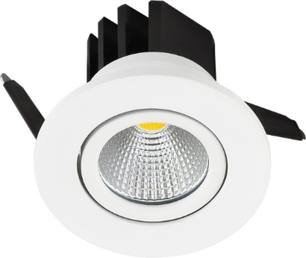

|  |  |
| --- | --- |
| Item No: | VT-1104RD |
| Shape | **Round** |
| Real Watts | **3W** |
| Voltage | **100~220V** |
| Input Frequency | **50/60Hz** |
| Input Efficiency | **70lm/w** |
| Lumen(lm) | **210lm** |
| PF | **>0.5** |
| RA | **>80** |
| Color Temperature | **3000K,6000K** |
| Beam Angle | **40’D** |
| LED Chip | **COB** |
| LED Qty | **1** |
| Color of Fixture | **Powder Coating Die cast (PKW)** |
| Protection Class | **IP20** |
| Body Material | **Aluminum** |
| Dimmable | **No** |
| Unit size |  |
| Life Time | **20000hrs** |
| Operation Temperature | **-25 ~50’C** |
| Applicable Environment | **Indoor Lighting, Used in Home down light** |



