A60 LED BULB
ITEM NO: VT-1853; WATTS: 10W
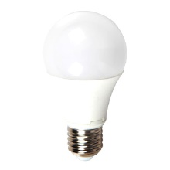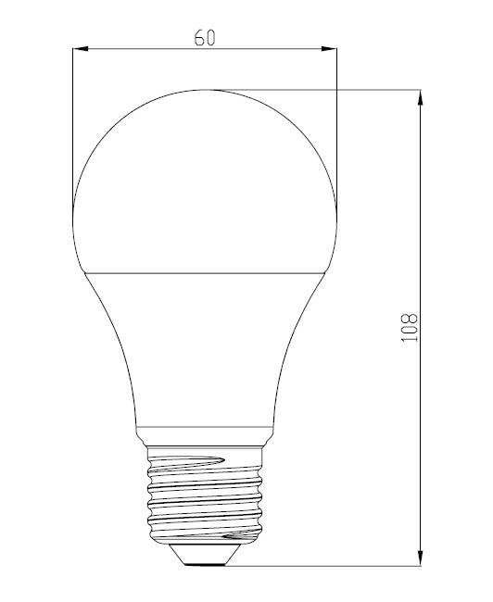

Item No: | VT-1853
SKU Codes | 4209:3000K
Type | A60
Base | E27
Real Watts | 10W
EQ. Watts | 60W
Voltage | 100-240V
Input Frequency | 50/60Hz
Input Current | 60ma
Input Efficiency | 80lm/w
Lumen(lm) | 806lm
PF | >0.7
CRI | >80
Color Temperature | 3000K,4500K,6000K
Beam Angle | 200’D
LED Chip | SMD 2835
LED Qty | 24
Driver | Non Isolated Constant Current Power
Protection Class | IP20
Body Material | Plastic
Dimmable | No
Unit size | 60*108mm
Life Time | 20000hrs
Applicable Environment | Indoor Lighting, Used in Home down light, Stairwell lighting.
Instruction Manual：
Installing please following below steps:
- Please note to cut off the power supply before replacing the lamp to prevent electric shock or lamp burning, choose to install to correspondingly lamp holders
- When try to tighten or take off the bulb, please clench radiator body by finger as shown below :

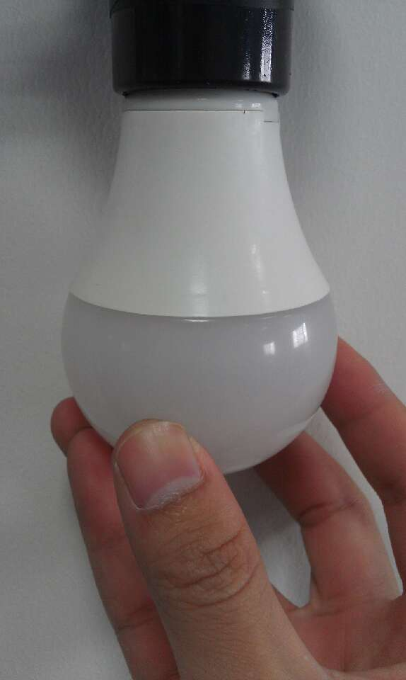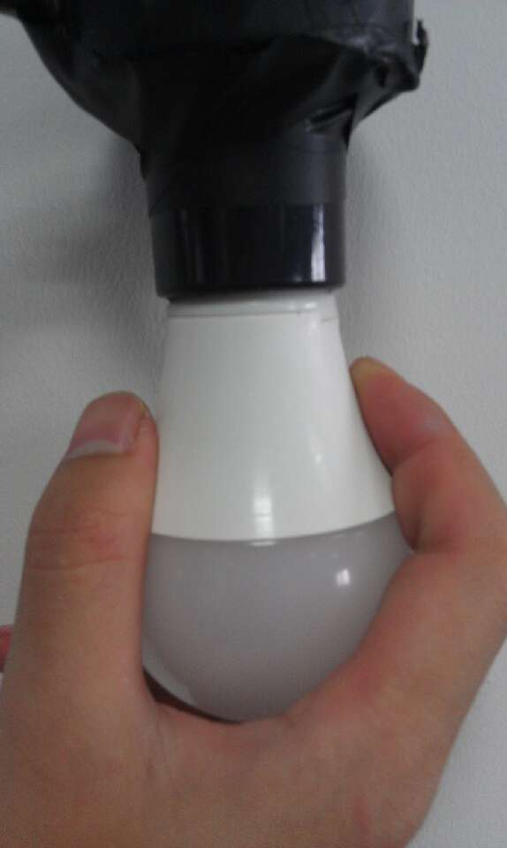

- When need to take off the bulb ,please wait 20minutes after turning off,so as not to burn your fingers

