LED BULBS
ITEM NO: VT-1929; WATTS:10W
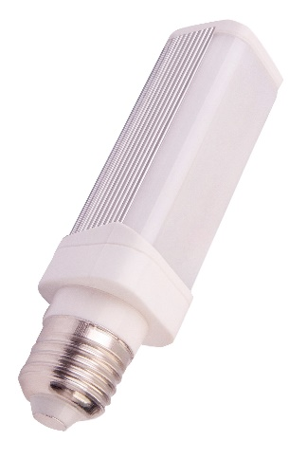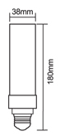
Item No: | VT-1929
SKU Codes | 4299:6000K
Base | E27
Real Watts | 10W
EQ. Watts | 100W
Voltage | 200~240V
Input Frequency | 50Hz
Input Current | 50ma
Input Efficiency | 85lm/w
Lumen(lm) | 850lm
PF | >0.6
RA | >80
Color Temperature | 4500K,6000K
Beam Angle | 120’D
LED Chip | EPISTAR
LED Type | SMD
LED Qty | 48
Protection Class | IP20
Body Material | Plastic
Color of Fixture | Powder Coating White ( PKW )
Dimmable | No
Unit size | 180mm*38mm
Life Time | 20000hrs
Operation Temperature | -25 ~50’C
Applicable Environment | Indoor Lighting, Used in Home down light, Stairwell lighting.

